*Florida International University*

*School of Computing and Information Sciences*

Software Engineering Focus

Final Deliverable

*Code by Cooking 0.0*

**Team Members:** Derrick Serbia, Dhrumel Shah

**Product Owner(s)**: Francisco Ortega

**Mentor(s)**: Francisco Ortega, Mohsen Taheri

**Instructor**: Masoud Sadjadi

The MIT License (MIT)

Copyright (c) *2016 Florida International University*

Permission is hereby granted, free of charge, to any person obtaining a copy of this software and associated documentation files (the "Software"), to deal in the Software without restriction, including without limitation the rights to use, copy, modify, merge, publish, distribute, sublicense, and/or sell copies of the Software, and to permit persons to whom the Software is furnished to do so, subject to the following conditions:

The above copyright notice and this permission notice shall be included in all copies or substantial portions of the Software.

THE SOFTWARE IS PROVIDED "AS IS", WITHOUT WARRANTY OF ANY KIND, EXPRESS OR IMPLIED, INCLUDING BUT NOT LIMITED TO THE WARRANTIES OF MERCHANTABILITY, FITNESS FOR A PARTICULAR PURPOSE AND NONINFRINGEMENT. IN NO EVENT SHALL THE AUTHORS OR COPYRIGHT HOLDERS BE LIABLE FOR ANY CLAIM, DAMAGES OR OTHER LIABILITY, WHETHER IN AN ACTION OF CONTRACT, TORT OR OTHERWISE, ARISING FROM, OUT OF OR IN CONNECTION WITH THE SOFTWARE OR THE USE OR OTHER DEALINGS IN THE SOFTWARE.

***Abstract***

*This document presents the design of our Virtual Reality application Code by Cooking. It reflects the Agile and Scrum methodology we used for developing the application. It includes the purpose of the system, the implemented features, the project plan, system design and its validation. It also contains a breakdown of the features we have worked on for each sprint.*

**Table of Contents**

**Introduction**……………………………………………………………………………………………....…………... 6

Current System ………………………………………………………………………………………………………... 6

Purpose of New System ………………………………………………………………………………………………………... 6

**User Stories**

Implemented User Stories ………………………………………………………………………………………………………... 7

Pending User Stories ………………………………………………………………………………………………..…..….. 11

**Project Plan**

Hardware and Software Resources …………………………………………………………………………………….……….……….… 12

Sprints Plan

…………………………………………………………………………………………..……………. 13

*Sprint 1* ……………………………………………………………………………………………………... 13

*Sprint 2* ……………………………………………………………………………………………………... 15

*Sprint 3* ……………………………………………………………………………………………………... 17

*Sprint 4*……………………………………………………………………………………………………... 19

*Sprint 5*……………………………………………………………………………………………………... 21

*Sprint 6*……………………………………………………………………………………………………... 22

**System Design**

Architectural Patterns …………………………………………………………………………………………………….….. 24

System and Subsystem Decomposition ………………………………………………………………………………….…………………...… 24

Deployment Diagram …………………………………………………………………..………………….………….....…… 26

Design Patterns …………………………………………………………………………………….…………………... 27

**System Validation** ………………………………………………………………………………………………………….... 28

**Glossary** …………………………………………………………………………………………………………… 45

**Appendix** …………………………………………………………………………………………………………… 46

Appendix A - UML Diagrams ……………………………………………………………………………………………………….... 46

Appendix B - User Interface Design  ……………………………………………………………………………………….………………... 55

Appendix C - Sprint Review Reports ……………………………………………………………………………………...…………………. 61

Appendix D - User Manuals, Installation/Maintenance Document, Shortcomings/Wishlist Document and other documents ………………………………………………………………….…………….……………………….. 67

**References**……………………………………………………………………………………………………………. 75

# 

# 

# 

# Introduction

*Code by Cooking* is a virtual reality application implemented in FIU’s ICAVE facility. The motivation behind building this application is to teach introductory programming to students by relating concepts to daily activities. The ICAVE contains five 9x5 foot high-resolution screens along with a handheld navigation device and a glasses-mounted head tracker. We have used these tools to allow students to interact with various components in a virtual reality environment. They can build code by engaging in different cooking activities such as chopping and frying and can view this code on a display to gain a better understanding of programming concepts.

## Current System

While we are not building on an existing application, there have been similar approaches to teaching programming such as Udemy’s “If you can Cook, you can Code” course where they explain concepts through video tutorials. However, students don’t get the opportunity to carry out cooking activities and build the code themselves. There are other websites that allow code building and interaction, but they fail to connect programming concepts with familiar activities.

## Purpose of New System

Our application resolves deficiencies in current teaching practices by educating our students in a virtual reality environment. It deviates from the current system by involving students in a more hands-on learning approach. Instead of reading code samples and typing them out, students can physically implement functions defined in the program. In this application, students can build functions by using various cooking tools available to them in the kitchen. They can pass parameters to these functions by using different cooking ingredients for each tool, enabling them to understand the concepts of functions and variables. Once they build the function, they can execute it by starting the cooking process and viewing the output. The application also demonstrates the concept of loops by giving students the option to select the number of times a given function can be executed. With this software, we have laid the foundation for the development of an introductory programming course with VR.

# User Stories

The following section provides the detailed user stories that were implemented in this iteration of the *Code by Cooking* project. These user stories served as the basis for the implementation of the project’s features. This section also shows the user stories that are to be considered for future development.

## Implemented User Stories

**User Story #926 - Learn Unity**

As a team developer, I need to learn about Unity software so that I can develop for the project.

**User Story #927 - Learn getReal3D plugin**

As a developer, I want to learn how to use the getReal3D plugin with unity so that I can use it to develop my application

**User Story #932 - Learn C#**

As a developer, I want to know how to write code in C# so that I can implement my application in this language

**User Story #934 - Learn getReal3D plugin**

As a team developer, I want to run the getReal3D plugin so that I can test the application/game developed in Unity

**User Story #944 - Learn Mingle/Scrum/Agile**

As a team developer, I want to learn how to use mingle for Scrum/Agile development so that I can complete my senior project

**User Story #941 - Learn C#**

As a team developer, I need to know how to write code in C# to develop scripts in Unity.

**User Story #948 - Learn Unity**

As a developer, I want to learn various functions in Unity so that I can develop a VR application

**User Story #1026 - Develop Unity VR Games**

As a developer, I want to practice the tutorials on the Unity website so that I can learn how to develop VR games

**User Story #955 - Training for I-Cave**

As an ICAVE developer, I want to participate in the ICAVE training session so that I can gain access to the facility

**User Story #1008 - Plan Project**

As a senior project student, I want to plan and finalize on the VR application so that I can begin development

**User Story #942 - Do the training for the FIU I-CAVE**

As a team developer, I need to attend the training for the ICAVE so that I can become a build master and develop the project at their lab.

**User Story #1014 - Come up with a project**

As a senior project student, I want to find a project idea that I feel is contributive to our current society so that I can spend time researching about it. It should also be something that is interesting to me so that I can be more productive

**User Story #1029 - Complete more advanced tutorials in Unity**

As a team developer, I want to complete advanced tutorials in order to learn more about Unity and how it can be used in this project.

**User Story #962 - View the kitchen facility**

As a student user, I want to be surrounded by a kitchen environment so that I can use various kitchen objects

**User Story #1023 - Move items in the kitchen**

As a student user, I want to be able to move items from one place to another so that I can use them for cooking

**User Story #960 - View pseudo-code**

As a student user, I want to be able to view the pseudo-code corresponding to the function performed so that I can understand how the code is implemented

**User Story #952 - Display and update text**

As a user, I want to see text when there is object interaction so that I have visual feedback

**User Story #949 - Environment in Unity**

As a user, I would like move/walk around a kitchen and see some objects that I would see in a real kitchen so that I feel as if I was in a kitchen

**User Story #1050 - Use various ingredients and equipment**

As a student user, I want to operate with various ingredients and equipment in the kitchen facility so that I can use them for cooking

**User Story #1051 - View pseudo-code on a screen**

As a student user, I want to operate with various ingredients and equipment in the kitchen facility so that I can use them for cooking

**User Story #1065 - Screen inside of the game**

As a user, I would like to see the text displayed in a screen similar to a TV so that the game feels more real and interactive

**User Story #1066 - Fix Visual Studio**

As a team member, I have to get visual studio fixed so that I can work on the scripts away from my team member.

**User Story #1074 - More objects in the kitchen**

As a user, I would like to see more objects in the kitchen, including more food and kitchen appliances, so that there are more objects to interact with

**User Story #1064 - Text updates when adding and removing stove objects**

As a user, I would like feedback when I switch from one function to the next so that I know that the program is responding to my actions.

**User Story #1078 - Use all facilities of the kitchen**

As a student user, I want to be able to use all the ingredients and equipment so that I can use them for cooking

**User Story #1081 - View pseudo-code for all functionalities**

As a student user, I want to be able to view the pseudo-code on the screen for all the functions I carry out so that I understand how the code is implemented for each function

**User Story #1109 - Add button to begin animations**

As a user, I would like to click on a button so that functions such as fry, boil, etc. can take place.

**User Story #1087 - See object/parameter that the function is using**

As a user, I would like the in-game screen to also display the object that the function is using. That way, I will know that the function is doing work on an object.

**User Story #1112 - View cooking process/output**

As a student user, I want to be able to view the cooking process and output so I can get a complete cooking experience

**User Story #1114 - View looping functionality**

As a student user, I want to be able to view multiple outputs for the same function so that I can understand how loops are used in programming

**User Story #1089 - Animations**

As a user, I would like to see animations to know when the functions are taking place.

## 

## Pending User Stories

None

# Project Plan

This section describes the planning that went into the realization of this project. This project incorporated the agile development techniques and as such required the sprints to be planned. These sprint plannings are detailed in the section. This section also describes the components, both software and hardware, chosen for this project.

## Hardware and Software Resources

The following is a list of all hardware and software resources that were used in this project:

**Hardware** (I-CAVE system)

* 5 9x5 feet high-resolution display screens with projectors
* 4x ARTtrack2 IR tracking cameras, with mounts
* 1x ARTtrack rack-mounted tracking controller
* 2x head-tracking optical targets for attaching to the supplied 3D glasses
* 2x hand-tracking optical targets for attaching to the supplied wireless gamepads
* 3x IR emitter blasters to provide IR sync to wireless 3D IR shutter glasses

**Software**

* Mechdyne GetReal3D 3.2.5
* Mechdyne DTrack2 control software
* Mechdyne trackd for integration of tracking and navigation devices
* Unity 5.3.2
* Microsoft Visual Studio
* Windows 7 Operating System
* Programming Language - C#
* Mingle
* Slack
* Google Hangouts
* Skype
* StarUML
* Github

## Sprints Plan

### Sprint 1

(8/29/2016 - 9/9/2016)

**User Story #926 - Learn Unity**

**Acceptance Criteria:**

1. Understand what Unity is used for.
2. Be able to develop using Unity.

**Related Tasks:**

#956 Unity Tutorials

#938 Read about Unity for the ICAVE

#937 Download Unity

**User Story #927 - Learn GetReal3D plugin**

**Acceptance Criteria:**

1. Install the getReal3d plugin
2. Learn how to create a project in unity with the plugin

**Related Tasks:**  
#1013 Download GetReal3D plugin  
#928 Learn how to use plugin with Unity

**User Story #932 - Learn C#**

**Acceptance Criteria:**

1. Get familiar with commands and syntax

**Related Tasks:**  
#933 Read documents on C#

**User Story #934 - Learn getReal3D plugin**

**Acceptance Criteria:**

1. getReal3D plugin setup
2. getReal3D plugin works with Unity

**Related Tasks:**

#940 Make it work with Unity

#939 Download Plugin

**User Story #944 - Learn Mingle/Scrum/Agile**

**Acceptance Criteria:**

1. Know how to use mingle for Scrum/Agile

**Related Tasks:**

#969 Mingle Tutorials

#967 Explore Mingle

**User Story #941 - Learn C#**

**Acceptance Criteria:**

1. Write scripts in C#

**Related Tasks:**

#646 Complete Unity tutorials for scripting

#961 Read scripting tutorial in Unity website

**User Story #948 - Learn Unity**

**Acceptance Criteria:**

1. Know how to set up a project
2. Know how to Create game objects
3. Know how to navigate using the controller simulator

**Related Tasks:  
#**1007 Unity tutorials with ICAVE  
#1006 Unity tutorial   
#951 Download unity

### Sprint 2

(9/12/2016 - 9/23/2016)

**User Story #1026 - Develop Unity VR Games**

**Acceptance Criteria:**

1. Learn how to create game objects
2. Learn how to add components to game objects
3. Learn how to control the camera
4. Learn how to add scripts
5. Learn how to move objects
6. Learn how to trigger events and carry out functions based on the specific event
7. Learn how to create preconfigured game objects or prefabs
8. Learn how to tag game objects

**Related Tasks:**  
#1028 Tank shooter game  
#1027 Unity game tutorial 1 - Roll a Ball

**User Story #955 - Train for I-Cave**

**Acceptance Criteria:**

1. Attend training
2. Learn how to use the icave facility
3. Have the development software available on personal computer

**Related Tasks:  
#**992 Attend training for ICave

**User Story #1008 - Plan Project**

**Acceptance Criteria:**

1. Decide on an icave VR application
2. Have the application accepted by the product owner
3. Plan the implementation details of the project

**Related Tasks:  
#**1020 Plan project implementation  
#1012 Consult product owner  
#1011 Brainstorm application to be developed

**User Story #942 - Do the training for the FIU I-CAVE**

**Acceptance Criteria:**

1. Attend training
2. Become build master

**Related Tasks:**

#972 Attend ICAVE training

**User Story #1014 - Come up with a project**

**Acceptance Criteria:**

1. Get a project idea approved

**Related Tasks:**

#1019 Finalize project’s details

#1016 Research - education with VR

#1015 Research - teaching programming to novice

**User Story #1029 - Complete more advanced tutorials in Unity**

**Acceptance Criteria:**

1. Completed various tutorials

**Related Tasks:**

#1030 Complete Tutorials

### Sprint 3

(9/26/2016 - 10/07/2016)

**User Story #962 - View the kitchen facility**

**Acceptance Criteria:**

1. Terrain should be present as a base for the environment
2. Assets such as walls, shelf, stove, refrigerator, pot and cooking ingredients should be present
3. Each object should be correctly positioned

**Related Tasks:**  
#1024 Position objects and assets  
#1022 Import kitchen assets  
#1021 Develop terrain

**User Story #1023 - Move items in the kitchen**

**Acceptance Criteria:**

1. User should be able to grab the pan and place it on the stove

**Related Tasks:  
#**1025 Move pan to stove

**User Story #960 - View pseudo-code**

**Acceptance Criteria:**

1. Display the method signature after the pan has been placed on the stove

**Related Tasks:**  
#1049 Display text on collision corresponding to the function  
#1048 Add Collision detection to stove

**User Story #952 - Display and update text**

**Acceptance Criteria:**

1. Text is updated when objects that represent variables and functions interact accordingly

**Related Tasks:**

#1072 Documentation

#1018 Review tutorials that teach updating text

#981 Develop object-object interaction

#980 Develop single object interaction with stove

**Diagrams:**

Fig. A.3

Fig. A.4

Fig. A.5

Fig. A.6

**User Story #949 - Environment in Unity**

**Acceptance Criteria:**

1. Being in a virtual kitchen

**Related Tasks:**

#1017 Review tutorials to create an environment

#978 Implement an environment using Unity

### Sprint 4

(10/10/2016 - 10/21/2016)

**User Story #1050 - Use various ingredients and equipment**

**Acceptance Criteria:**

1. Have the items accessible to the user in the kitchen
2. Allow the user to use these items for cooking

**Related Tasks:**  
#1053 Add functionality to each asset  
#1052 Import assets for ingredients and equipment

**User Story #1051 - View pseudo-code on a screen**

**Acceptance Criteria:**

1. User should be able to view the screen
2. User should be able to view code on the screen

**Related Tasks:**  
#1055 Display code on the screen  
#1054 Import a screen

**Diagrams:**

Fig. A.8

**User Story #1065 - Screen inside of the game**

**Acceptance Criteria:**

1. An object similar to a TV screen will display the text updated

**Related Tasks:**

#1070 Make the screen display the updated text

#1069 Create TV/Floating screen that user can look at

**User Story #1066 - Fix Visual Studio**

**Acceptance Criteria:**

1. Visual studio works on campus

**Related Tasks:**

#1071 Visit techlab

#1068 Visit techlab 10/10

#1067 Visit techlan 9/26

**User Story #1074 - More objects in the kitchen**

**Acceptance Criteria:**

1. See a variety of foods
2. See more kitchen appliances (such as cooking pot, coffee maker, blender, etc)

**Related Tasks:**

#1076 Add items to scene

#175 Fix rigidbodies and colliders

**User Story #1064 - Text updates when adding and removing stove objects**

**Acceptance Criteria:**

1. Display is updated when I select a different function
2. Updates every time

**Related Tasks:**

#1095 Documentation

#1094 Script to update text on in-game display

**Diagrams:**

Fig. A.4

Fig. A.6

### Sprint 5

(10/24/2016 - 11/04/2016)

**User Story #1078 - Use all facilities of the kitchen**

**Acceptance Criteria:**

1. Have all the ingredients and equipment accessible to the user
2. User should be able to use all these items for cooking

**Related Tasks:**  
#1080 Add functionality to all the assets  
#1079 Import all remaining assets

**User Story #1081 - View pseudo-code for all functionalities**

**Acceptance Criteria:**

1. View pseudo-code on the screen when starting function
2. View no pseudo-code for that function when it is over

**Related Tasks:  
#**1128 Modify OnTriggerExit function and Update  
#1084 Modify OnCollisionExit function and Update  
#1083 Modify OnTriggerEnter function and Update

**Diagrams:**

Fig. A.9 , Fig. A.10 , Fig. A.11

**User Story #1109 - Add button to begin animations**

**Acceptance Criteria:**

1. Clickable button that will begin animation/function

**Related Tasks:**

#1110 Add button to in-game screen

**User Story #1087 - See object/parameter that the function is using**

**Acceptance Criteria:**

1. The screen displays the current function and the parameter/object that has been passed to it

**Related Tasks:**

#1111 Cleanup script

#1091 Edit objects’ components to accommodate the script

#1088 Create script

**Diagrams:**

Fig. A.3

Fig. A.5

### Sprint 6

(11/07/2016 - 11/18/2016)

**User Story #1112 - View cooking process/output**

**Acceptance Criteria:**

1. User must be able to begin cooking using the pointing wand
2. User must be able to view the process when cooking starts
3. User must be able to view the output of the process

**Related Tasks:  
#**1116 Display the process and the output  
#1115 Accept user input to start the process

**Diagrams:**

Fig. A.12

**User Story #1114 - View looping functionality**

**Acceptance Criteria:**

1. User must be able to Indicate number of output items
2. User must be able to view process with multiple outputs based on the number indicated
3. User must be able to view the pseudocode containing a loop

**Related Tasks:  
#**1121 Display pseudocode containing the loop  
#1120 Display process for multiple output items  
#1118 Create functionality for multiple cups/mugs

**Diagrams:**

Fig. A.13

**User Story #1089 - Animations**

**Acceptance Criteria:**

1. Animations start when I start the function
2. Animation produces an output

**Related Tasks:**

#1090 Review animations tutorial

**Diagrams:**

Fig. A.7

# System Design

This section describes the high level system design of our *Code by Cooking 0.0* Virtual Reality application. It includes details on the architectural patterns, system and subsystem decomposition, deployment diagram and design patterns.

## Architectural Patterns

Our application follows the Model View Controller architecture as it closely resembles the interaction pattern of different components in our system. The Model includes all the entity objects that are used for cooking. The View includes the main display screens in the ICAVE and the Code Menu. The Controller includes the Platform, the Stove and the Wands. The Controller controls the different Model objects and their interactions, while updating the View accordingly.

## System and Subsystem Decomposition

The Model refers to all the entity objects that are used for cooking such as the pan, pot, chopper and blender and also all the food items that go into these objects. The cooking objects are split into Platform Objects (blender, chopper) and Stove Objects (pan, pot) depending on where they are placed. Each of them have either the *PlatformObj.cs* script or the *StoveObject.cs* script attached to it in order to interact with the food items placed in them. The food items that go into the Stove Objects also have the *FoodItem.cs* script attached to each of them to store information about the food and change material when needed.

The View refers to the Code Menu and ICAVE display. The Code Menu displays the functions carried out by the cooking objects and the parameters of those functions which are the food items. The display screens on the ICAVE form the visual for the entire application.

The Controller refers to the Platform, the Stove, the Grabbing Wand and the Pointing Wand. They update the Code Menu and the ICAVE display based on the functions carried out by the cooking objects.

The Platform controls the Platform Objects and updates the display when these objects collide with the platform, and when food items enter these objects. It also carries out the blending and chopping functions and displays the process and output. These functions are carried out in the *Platform.cs* script attached to the Platform.

The Stove controls the Stove Objects and updates the display when these objects enter the stove, and when food items enter these objects. It also carries out the frying and boiling functions and displays the process and output. These functions are carried out in the *stove.cs* script attached to the Stove.

The Grabbing Wand is used to grab the cooking objects and food items and move them around. It has the *GrabbingWand.cs* script attached to it. The Pointing Wand is used to start the cooking process by pressing the button on the Code Menu for the Stove Objects and by pointing at (making contact and pressing the wand button) the Platform Objects. It has the *PointingWand.cs* script attached to it. The *WandManager.cs* script allows the user to switch control between the grabbing and pointing wands.

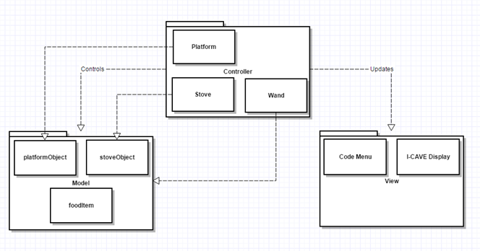

##### Fig 1 - Architecture with System and Subsystem Decomposition

## Deployment Diagram

Kitchen.exe is the Unity application containing all the project files developed by us. It runs only on Windows. It uses the GetReal3D 3.2.5 plugin which needs to be installed along with the Unity 5.3.2 application on the main computer that is connected to the ICAVE. GetReal3D contains scripts that control the Hand and Head devices operated by the user, along with the Wand Manager and the Grabbing Wand. The Pointing Wand script along with all the other scripts developed by us is part of the kitchen.exe application.

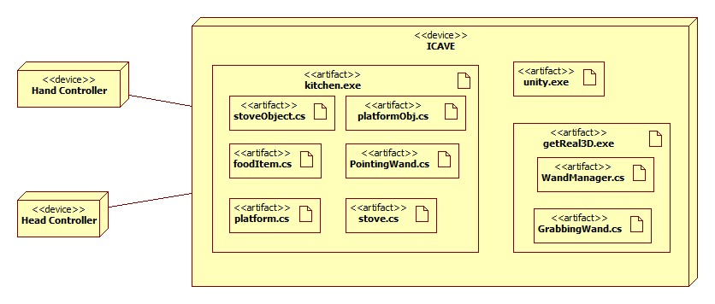

## 

##### Fig 2 - Deployment Diagram

## 

## Design Patterns

**Mediator**

In our application, the Platform and the Stove behave as the mediators between the cooking objects and the text fields in the Code Menu. Every interaction that takes place between them has to go through the Mediator. This allows for loose coupling between various system components.

**State**

Our application follows the State pattern as the food items and the cooking objects are associated with particular states and their behavior is dependent upon it. Functions can be carried out on them only when they are in a certain state.

## 

## 

## 

## 

## 

## 

## 

## System Validation

**Unit Tests**

**User Story # 960 - View Pseudocode**

**Test Case 1: Sunny Day**

**Purpose:**

* To test that the *stove.cs* script will display function as soon as the pan touches the stove. Once the pan is dropped or placed on the stove, the text should display: *fry( )*

**Precondition:**

* The application has been executed
* The user is grabbing the pan
* The user is close enough to the stove so that he/she can create direct contact between the stove and the pan

**Test Procedure:**

1. The user moves the pan on top of the stove and lets it go.

**Expected Result:**

1. The pan will stay on top of the stove
2. The text displayed will be *fry( )*

**Actual Result:**

1. The pan stayed on top of the stove
2. The program displayed *fry( )*

**Test Case 2: Rainy Day**

**Purpose:**

* To test that the *stove.cs* script will not display function if the pan has been dropped but not touched the stove

**Precondition:**

* The application has been executed
* The user is grabbing the pan

**Test Procedure:**

1. The user grabs the pan and drops it on the floor

**Expected Result:**

1. The display will not update

**Actual Result:**

1. The display does not update

**User Story # 1051 - View pseudocode on a screen**

**Test Case 1: Sunny Day**

**Purpose:**

* To test that the *Platform.cs* script displays the function as soon as the platformObject touches the platform

**Precondition:**

* The application has been executed
* The user is grabbing the platformObject
* The user is close enough to the platform so that he/she can create direct contact between the platformObject and the platform

**Test Procedure:**

1. The user moves the platformObject on top of the platform and lets it go

**Expected Result:**

1. The platformObject will stay on top of the platform
2. The screen displays *platformObject( )*

**Actual Result:**

1. The platformObject stays on top of the stove
2. The program displays *platformObject( )*

**Test Case 2: Rainy Day**

**Purpose:**

* To test that the *Platform.cs* script does not display the function twice if the platformObject touches the platform twice

**Precondition:**

* The application has been executed
* The user is grabbing the platformObject
* The user is close enough to the platform so that he/she can create direct contact between the platformObject and the platform

**Test Procedure:**

1. The user moves the platformObject on top of the platform
2. The user hits the platform with the platformObject without dropping it
3. The user then hits it again before dropping it

**Expected Result:**

1. The platformObject will stay on top of the platform
2. The screen displays *platformObject( )* just once

**Actual Result:**

1. The platformObject stays on top of the stove
2. The screen displays *platformObject( )* just once

**User Story # 1081 - View pseudocode for all functionalities**

**Test Case 1: Sunny Day**

**Purpose:**

* To test that the *platform.cs* and *platformObject.cs* script displays the function parameter as soon as the food touches the platformObject

**Precondition:**

* The application has been executed
* The user is grabbing the food
* The user is close enough to the platformobject so that he/she can create direct contact between the food and platformObject

**Test Procedure:**

1. The user moves the food on top of the platformObject and lets it go

**Expected Result:**

1. The food will stay in the platformObject
2. The screen displays *platformObject(food )*

**Actual Result:**

1. The food stays in the platformObject
2. The program displays *platformObject(food )*

**Test Case 2: Rainy Day**

**Purpose:**

* To test that the *platform.cs* and *platformObject.cs* script does not display the function parameter if the food dropped into the blender is not a fruit

**Precondition:**

* The application has been executed
* The user is grabbing a potato
* The user is close enough to the blender

**Test Procedure:**

1. The user moves the potato on top of the blender and drops it

**Expected Result:**

1. The potato will stay in the blender
2. The screen displays *blend()* without the potato as parameter

**Actual Result:**

1. The potato will stay in the blender
2. The screen displays *blend()* without the potato as parameter

**Test Case 3: Sunny Day**

**Purpose:**

* To test that the *platform.cs* and *platformObject.cs* script displays the updated function as soon as the food exits the platformObject

**Precondition:**

* The application has been executed
* The user is grabbing the food

**Test Procedure:**

1. The user moves the food away from the platformObject

**Expected Result:**

1. The screen displays *platformObject( )*

**Actual Result:**

1. The program displays *platformObject( )*

**Test Case 4: Sunny Day**

**Purpose:**

* To test that the *platform.cs* and *platformObject.cs* script displays the updated function as soon as the platformObject exits the platform

**Precondition:**

* The application has been executed
* The user is grabbing the platformObject

**Test Procedure:**

1. The user moves the platformObject away from the platform

**Expected Result:**

1. The screen display does not include that particular platformObject

**Actual Result:**

1. The screen display does not include that particular platformObject

**User Story # 1112 - View cooking process/output**

**Test Case 1: Sunny Day**

**Purpose:**

* To test that the *platform.cs* and *PointingWand.cs* script display the process and output of the chopping function followed by updating the code display when user points to the chicken

**Precondition:**

* Chicken has been placed on the chopping board which is placed on the platform and the display has been updated to the function and its parameter

**Test Procedure:**

1. The user points the pointing wand towards the chicken and presses the wand button

**Expected Result:**

1. Chopping process is carried out and the un-chopped chicken is replaced with the chopped chicken
2. The screen display is updated with *Chicken* removed from *Chop()*

**Actual Result:**

1. Chopping process is carried out and the un-chopped chicken is replaced with the chopped chicken
2. The screen display is updated with *Chicken* removed from *Chop()*

**Test Case 2: Sunny Day**

**Purpose:**

* To test that the *platform.cs* and *PointingWand.cs* script display the process and output of the chopping function followed by updating the code display when user points to the chopping board

**Precondition:**

* Chicken has been placed on the chopping board which is placed on the platform and the display has been updated to the function and its parameter

**Test Procedure:**

1. The user points the pointing wand towards the chopping board and presses the wand button

**Expected Result:**

1. Chopping process is carried out and the un-chopped chicken is replaced with the chopped chicken
2. The screen display is updated with *Chicken* removed from *Chop()*

**Actual Result:**

1. Chopping process is carried out and the un-chopped chicken is replaced with the chopped chicken
2. The screen display is updated with *Chicken* removed from *Chop()*

**Test Case 3: Rainy Day**

**Purpose:**

* To test that the *platform.cs* and *PointingWand.cs* script do not start the chopping process when user points to the platform

**Precondition:**

* Chicken has been placed on the chopping board which is placed on the platform and the display has been updated to the function and its parameter

**Test Procedure:**

1. The user points the pointing wand towards the platform and presses the wand button

**Expected Result:**

1. Chopping process is not carried out
2. The screen display does not change

**Actual Result:**

1. Chopping process is not carried out
2. The screen display does not change

**User Story # 1114 - View looping functionality**

**Test Case 1: Sunny Day**

**Purpose:**

* To test that the *platform.cs* and *PointingWand.cs* script displays the loop as soon as the blending process begins and runs as many iterations as the number of glasses. The system must also display those glasses filled with juice while emptying a proportionate amount of juice from the blender. This test case is carried out for 4 glasses.

**Precondition:**

* Blender has been placed on the platform with the food inside it and the display updated

**Test Procedure:**

1. The user grabs 4 glasses, one at a time, and places them on the platform
2. The pointing wand is pointed at the blender and the wand button is pressed

**Expected Result:**

1. The display is updated with the loop
2. The blending process is carried out, replacing the fruits inside the blender with juice
3. Juice is filled in all 4 glasses and an equivalent amount of juice is emptied from the blender

**Actual Result:**

1. The display is updated with the loop
2. The blending process is carried out, replacing the fruits inside the blender with juice
3. Juice is filled in all 4 glasses and an equivalent amount of juice is emptied from the blender

**Test Case 2: Sunny Day**

**Purpose:**

* To test that the *platform.cs* and *PointingWand.cs* script displays the loop as soon as the blending process begins and runs as many iterations as the number of glasses. The system must also display those glasses filled with juice while emptying a proportionate amount of juice from the blender. This test case is carried out for 1 glass.

**Precondition:**

* Blender has been placed on the platform with the food inside it and the display updated

**Test Procedure:**

* 1. The user grabs the glass and places it on the platform
  2. The pointing wand is pointed at the blender and the wand button is pressed

**Expected Result:**

1. The display is updated with the loop
2. The blending process is carried out, replacing the fruits inside the blender with juice
3. Juice is filled in the glass and an equivalent amount of juice is emptied from the blender

**Actual Result:**

1. The display is updated with the loop
2. The blending process is carried out, replacing the fruits inside the blender with juice
3. Juice is filled in the glass and an equivalent amount of juice is emptied from the blender

**Test Case 3: Rainy Day**

**Purpose:**

* To test that the *platform.cs* and *PointingWand.cs* script does not display the loop as soon as the blending process begins if no glasses are present on the platform. The glasses must remain empty and the blender must remain full.

**Precondition:**

* Blender has been placed on the platform with the food inside it and the display updated

**Test Procedure:**

* 1. The pointing wand is pointed at the blender and the wand button is pressed, with no glasses on the platform

**Expected Result:**

1. The display does not contain a loop
2. The blending process is carried out, replacing the fruits inside the blender with juice
3. No juice is displayed in the glass, while the blender contains all the juice

**Actual Result:**

1. The display does not contain a loop
2. The blending process is carried out, replacing the fruits inside the blender with juice
3. No juice is displayed in the glass, while the blender contains all the juice

**User Story # 1064 - Text updates when adding and removing stoveObjects**

**Test Case 1 - Sunny Day**

**Title:** Update Code Menu when stoveObject enters the stove’s trigger

**Description:** When a stoveObject enters the stove trigger, the Code Menu should only display one line of texts with the correct function name.

**Precondition:**

1. Student is grabbing a stoveObject and is close enough to the stove to make contact.

**Test Steps:**

1. Move the stoveObject above the stove.
2. Drop or place the stoveObject directly on the stove.
3. View one line of text with the corresponding function name.

**Expected Results:**

1. The stoveObject should stay on top of the stove after it has been released.
2. The Code Menu should display one line of text with the correct function name.

**Actual Results:**

1. The stoveObject placed on the stove remained on top of the stove.
2. The Code Menu displayed a line of text with the corresponding function name.

**Pass/Fail:** Pass

**Test Case 2 - Sunny Day**

**Title:** Update Code Menu when stoveObject exits the stove’s trigger.

**Description:** When a stoveObject exits the stove trigger, the Code Menu should only remove the corresponding line of code.

**Precondition:**

1. A stoveObject is placed on the stove.
2. The Code Menu shows the correct line of code for this object.

**Test Steps:**

1. Using the GrabbingWand, grab the stoveObject that is on top of the stove.
2. While holding down the grab button, move the stoveObject away from the stove.

**Expected Results:**

1. The Code Menu will delete the line of code that corresponds to the stoveObject that was removed.

**Actual Results:**

1. The Code Menu removes the line of code corresponding to the object that has been removed from the stove.

**Pass/Fail:** Pass

**Test Case 3 - Rainy Day**

**Title:** Do not display multiple text lines for the same stoveObject

**Description:** Test whether the Code Menu will display the code for the same stoveObject.

**Precondition:** Student is grabbing a stoveObject and is close enough to the stove to make contact.

**Test Steps:**

1. Move the stoveObject above the stove.
2. While grabbing the stoveObject and holding down the grab button, move the stoveObject up and down quickly (going through the stove is ok).

**Expected Results:**

1. Code Menu should only display one line of text for the stoveObject being grabbed.

**Actual Results:**

1. Code Menu updates correctly every time the stoveObject enters and exits the stove trigger/collider.

**Pass/Fail:** Pass

**User Story # 1087 - See object/parameter that the function is using**

**Test Case 1 - Sunny Day**

**Title:** Update Code Menu when a foodItem enters a stoveObject’s trigger

**Description:** Test whether the Code Menu will update correctly when a foodItem is placed on a stoveObject. The stoveObject should be on top of the stove and the Code Menu must be displaying the correct function.

**Precondition:**

1. A stoveObject is on the stove.
2. The Code Menu is displaying the code for the stoveObject on it.
3. There is a foodItem nearby that can be placed on the stoveObject.

**Test Steps:**

1. Using the GrabbingWand, grab a foodItem and place it above the stoveObject.
2. Drop or place the foodItem on the stoveObject

**Expected Results:**

1. Code Menu will update.
2. Code Menu will replace the *objectToCook* parameter of the function with the name of the fooItem placed on the stoveObject.

**Actual Results:**

1. Code Menu updates and displays the function name with the foodItem’s name as a parameter.

**Pass/Fail:** Pass

**Test Case 2 - Sunny Day**

**Title:** Update Code Menu when a foodItem exits a stoveObject’s trigger

**Description:** Test whether the Code Menu will update correctly when a foodItem is removed from a stoveObject. The stoveObject should be on top of the stove and the Code Menu must be displaying the correct function.

**Precondition:**

1. A stoveObject is on the stove.
2. The Code Menu is displaying the code for the stoveObject on it.
3. There is a foodItem on the stoveObject.

**Test Steps:**

1. Using the GrabbingWand, grab a foodItem that is on the stoveObject.
2. Move the foodItem away from the stoveObject.

**Expected Results:**

1. Code Menu will update.
2. Code Menu will replace the name of the foodItem with *objectToCook*.

**Actual Results:**

1. Code Menu updates and displays the function name with *objectToCook* as a place holder for a new variable.

**Pass/Fail:** Pass

**Test Case 3 - Rainy Day**

**Title:** Update parameter of function for non-cookable foodItem

**Description:** Test whether the Code Menu will display the name of a foodItem that is not compatible with the pan or the pot.

**Precondition:**

1. A stoveObject is on the stove.
2. The Code Menu is displaying the function for the corresponding stoveObject.
3. There is a foodItem nearby that cannot be cooked.

**Test Steps:**

1. Using the GrabbingWand, grab a foodItem and place it on the stoveObject.
2. The Code Menu will display the name of the non-cookable foodItem.

**Expected Results:**

1. Code Menu will update.
2. Code Menu will replace *objectToCook* with the name of the foodItem.

**Actual Results:**

1. Code Menu updates and displays the function name with the name of the non-cookable foodItem.

**Pass/Fail:** Pass

**User Story # 1109 - Add button to begin animation**

**Test Case 1 - Sunny Day  
Title:** Button in Code Menu activates when foodItem enters an active stoveObject

**Description:** When a foodItem enters a stoveObject that is on the stove, the button on the Code Menu corresponding to this stoveObject will absorb the function cook for the foodItem.

**Precondition:**

1. There is a stoveObject on the stove.
2. User is close enough to an uncooked foodItem.

**Test Steps:**

1. Grab an uncooked foodItem.
2. Using the GrabbingWand, move the uncooked foodItem towards the stoveObject.
3. Drop/place the uncooked foodItem on the stoveObject.
4. Code Menu will display the correct function and the foodItem combination.
5. Button absorbs the function cook for the foodItem.

**Expected Results:**

1. The Code Menu will display *stoveObject’s function(foodItem’s name)*.
2. The button next to this line of code will acquire the cook function for foodItem.
3. The user will be able to press the button in order for the cook function to take place.

**Actual Results:**

1. The Code Menu displays correct line of code and activates button.
2. The button acquires cook function for foodItem.
3. The user is able to press on the button.
4. Cook function takes place after the button is pressed.

**Pass/Fail:** Pass

**Test Case 2 - Sunny Day**

**Title:** Button in Code Menu becomes inactive when foodItem removed

**Description:** Test whether the button loses functionality when the foodItem corresponding to it is removed from the stoveObject.

**Precondition:**

1. There is a stoveObject on the stove.
2. There is an uncooked foodItem on the stoveObject.
3. The button for the foodItem is active and listening for press.

**Test Steps:**

1. Using the GrabbingWand, remove the foodItem from the stoveObject.
2. Button will lose functionality.
3. Press on button where foodItem was present.

**Expected Results:**

1. After pressing the button where the foodItem was removed from, no foodItem will change state.

**Actual Results:**

1. No foodItem changed state after pressing on the button where the foodItem was removed from.

**Pass/Fail:** Pass

**Test Case 3 - Rainy Day**

**Title:** Button in Code Menu becomes inactive when stoveObject is removed while a foodItem is in it

**Description:** Test whether the button loses functionality when the an occupied stoveObject is removed from the stove.

**Precondition:**

1. There is a stoveObject on the stove.
2. There is an uncooked foodItem on the stoveObject.
3. The button for the foodItem is active and listening for press.

**Test Steps:**

1. Using the GrabbingWand, remove the stoveObject that has the uncooked foodItem in it.
2. Code Menu updates the line of code.

**Expected Results:**

1. After removing the stoveObject the Code Menu will update and the button will be removed.

**Actual Results:**

1. Code Menu updates after the stoveObject is removed and the button becomes inactive.

**Pass/Fail:** Pass

**User Story # 1089 - Animations**

**Test Case 1 - Sunny Day**

**Title:** Button in Code Menu should only modify corresponding foodItem

**Description:** Test whether the cook function mutates the value of the corresponding foodItem or if it affects other foodItems as well.

**Precondition:**

1. There is a stoveObject on the stove.
2. There is a foodItem on the stoveObject.
3. The Code Menu displays correct line of code.
4. The button corresponding to this line of code contains the correct cook function.

**Test Steps:**

1. Select the PointingWand in order to interact with the Code Menu.
2. Move the wand towards the button that the user desires to press.
3. User presses on Code Menu button.
4. Cook function only takes place for the foodItem that corresponds to the button.

**Expected Results:**

1. Cook function should take place when button is pressed.
2. Cook function should only take place for the foodItem that corresponds to the button.

**Actual Results:**

1. Cook function takes place and only for the foodItem that corresponds to the button.

**Pass/Fail:** Pass

**Test Case 2 - Rainy Day**

**Title:** Button in Code Menu does not function for non-cookable foodItem

**Description:** Test that the button does not update/change/modify any foodItems when the foodItem that corresponds to the button does not contain a cook function.

**Precondition:**

1. There is a stoveObject on the stove.
2. There is a non-cookable foodItem nearby.
3. The Code Menu displays correct line of code.

**Test Steps:**

1. Select the GrabbingWand.
2. Grab the non-cookable foodItem and place it on the stoveObject.
3. Change to the PointingWand.
4. Click on the button corresponding to the foodItem-stoveObject combination form step 2.

**Expected Results:**

1. Nothing is changed in the environment.

**Actual Results:**

1. The environment did not change.

**Pass/Fail:** Pass

**Integration Test**

**Test Case 1 - Sunny Day**

**Title:** Cooking process

**Description:** Testing the interaction of multiple objects and scripts of the system.

**Precondition:**

1. The application has just been launched.
2. All game objects are in place.
3. User is inside the cave with the head mount and the controller.

**Test Steps:**

1. Select the GrabbingWand by pressing on the Select Wand button until the blue-colored wand is show.
2. Walk towards the chopping board until you’re close enough that the wand can go through the board.
3. While pointing the wand through the chopping board, press and hold down the Activate Wand button. Now the chopping board is attached to the wand and you can move board around.
4. While still holding down the Activate Wand button, walk towards the platform and place the chopping board on top of if by releasing the Activate Wand button.
5. Change the wand to the Pointing Wand by pressing the Select Wand button until the green-colored wand is shown.
6. Point the wand at the chicken or the board making sure that the wand goes through either one of these objects.
7. Press the Activate Wand button. Within seconds, the chicken will be chopped into smaller pieces.
8. Change back to the GrabbingWand.
9. Move towards the stove.
10. Grab the frying pan and place it on the stove.
11. Grab one of the chicken pieces and place it on top of the frying pan.
12. Change back to the PointingWand.
13. Locate the line on the Code Menu that reads “Fry(chicken)”.
14. Point to the button next to the line located previously making sure that the button highlights (indicating that the wand is touching the button).
15. Once the button is highlighted, press on the Activate Wand button to start the cooking function.

**Expected Results:**

1. The whole chicken will be placed on the cutting board and the Code Menu will dislpay Chop(chicken).
2. After activating the chop function, the whole chicken will be cut into smaller pieces.
3. One of these chicken pieces will be placed on the frying pan and the Code Menu will display Fry(Chicken).
4. After pressing the correct button, the texture of the chicken piece will change indicating that the chicken has been fried.

**Actual Results:**

1. The Code Menu updated correctly when the chicken was placed on the chopping board.
2. The whole chicken was chopped into smaller pieces.
3. The Code Menu updated correctly when the chicken piece was placed on the frying pan.
4. The chicken piece changed texture once Cook was pressed for the chicken piece.

**Pass/Fail:** Pass

# 

# Glossary

**ICAVE:** Integrated Computer Augmented Virtual Environment (I-CAVE) is an instructional and research visualization facility located on FIU’s Modesto Maidique Campus.

**Unity:** A cross-platform game engine developed by Unity Technologies and used to develop video games for PC, consoles, mobile devices and websites.

**GetReal3D:** Plug-in that makes the Unity game engine compatible with virtual reality equipment, such as the CAVE™ or head-mounted displays.

**Agile:** Describes a set of principles for software development under which requirements and solutions evolve through the collaborative effort of self-organizing cross-functional teams.

**Mingle:** An Agile project management application from ThoughtWorks Studios for teams that need to make real-time decisions using real-time data. Mingle provides project intelligence and supports all team activity.

**C#:** Object-oriented programming language used to develop in Unity.

**Pseudo-code:** Simplified version of programming code.

**Udemy:** Website for learning and teaching where students are mastering new skills.

# Appendix

## 

## Appendix A - UML Diagrams

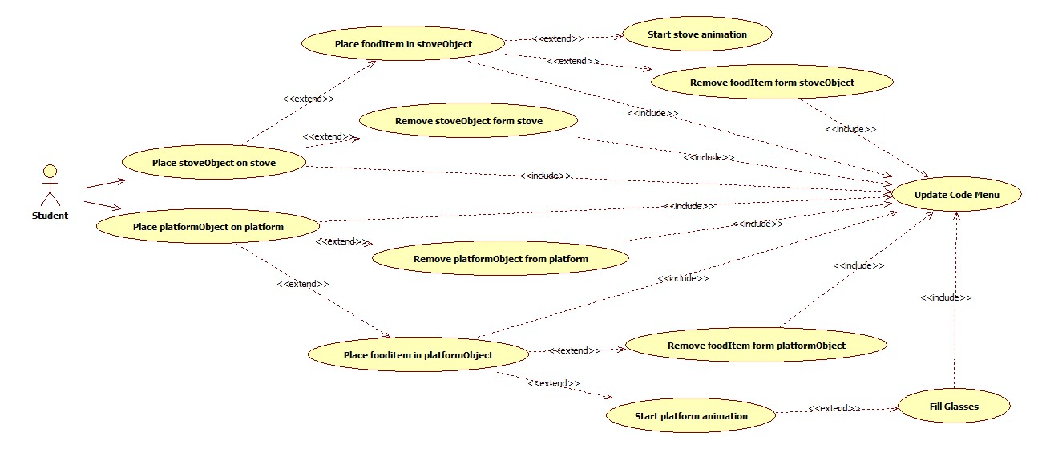

Fig. A.1 - Use Case Model

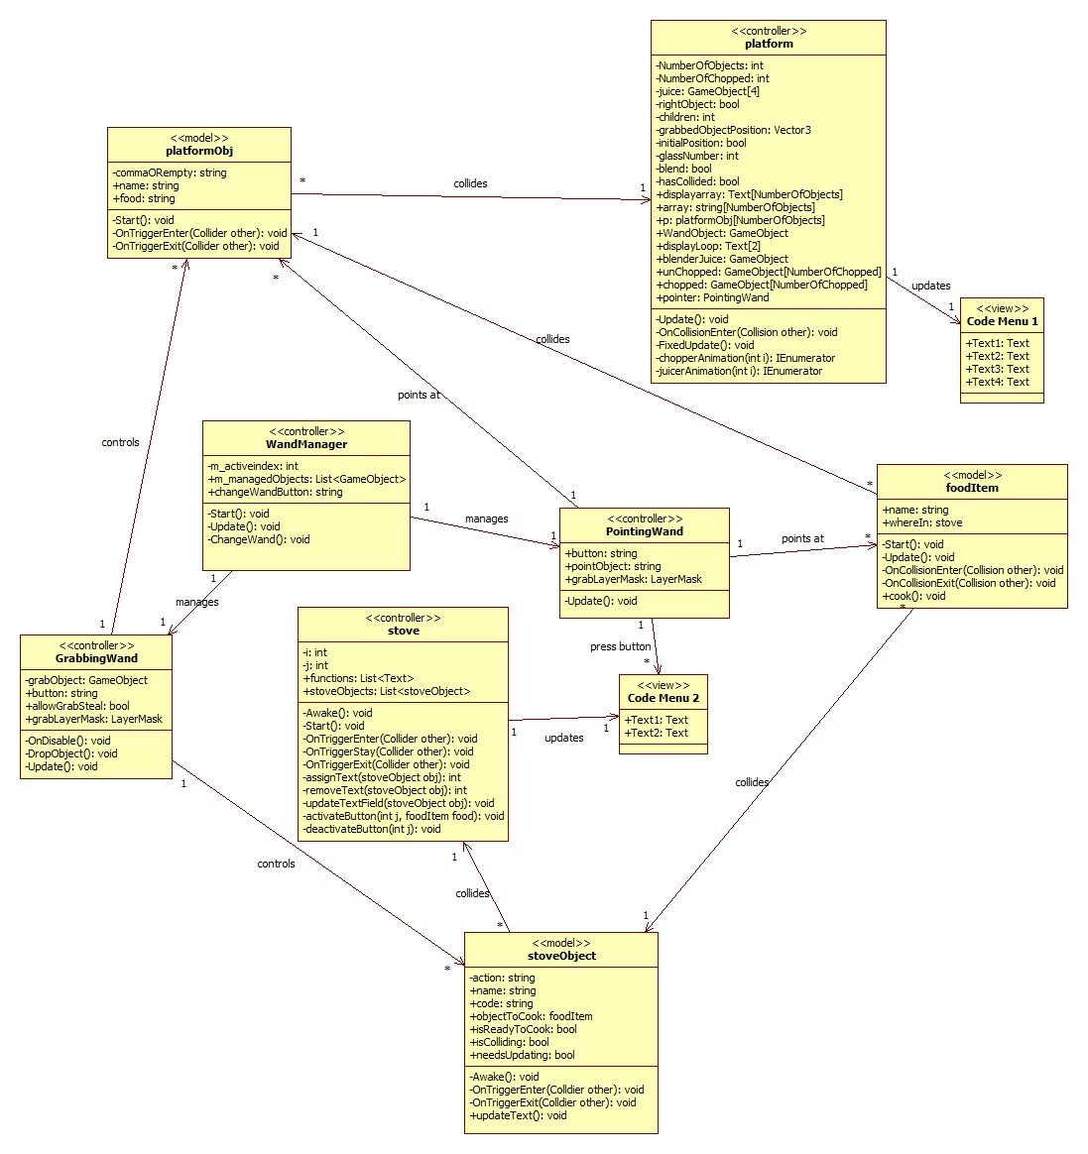

## 

Fig A.2 - Class Diagram

## 

##### Fig. A.3 - Sequence Diagram 1: Place foodItem on stoveObject

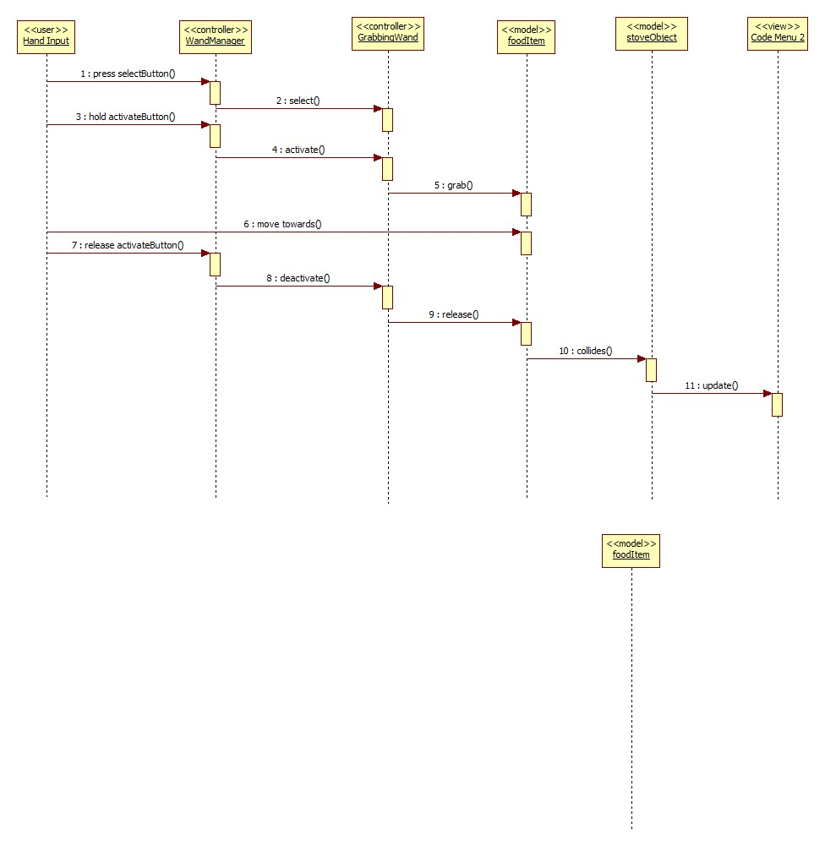

##### Fig. A.4 - Sequence Diagram 2: Place stoveObject on stove

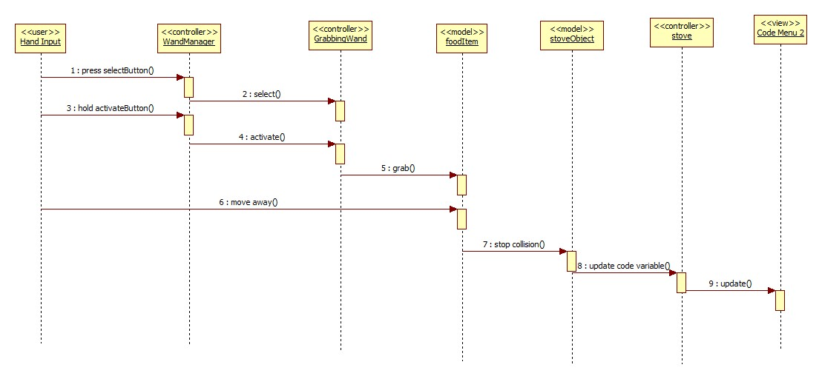

##### Fig. A.5 Sequence Diagram 3: Remove foodItem from stoveObject

##### 

##### 

##### 

##### 

##### 

##### 

##### 

##### 

##### Fig. A.6 - Sequence Diagram 4: Remove stoveObject from stove

## 

## 

## 

## 

## 

## 

## 

## 

##### Fig. A.7 - Sequence Diagram 5: Start stove animation

## 

## 

## 

## 

## 

##### 

##### Fig. A.8 - Sequence Diagram 6: Place PlatformObject on Platform

## 

##### Fig. A.9 - Sequence Diagram 7: Remove PlatformObject from Platform

## 

## 

##### Fig. A.10 - Sequence Diagram 8: Place FoodItem in PlatformObject

##### 

##### 

##### Fig. A.11 - Sequence Diagram 9: Remove FoodItem from PlatformObject

## 

## 

##### Fig. A.12 - Sequence Diagram 10: View cooking process/output for PlatformObject

##### Fig. A.13 - Sequence Diagram 11: View looping functionality by filling glasses

## Appendix B - User Interface Design

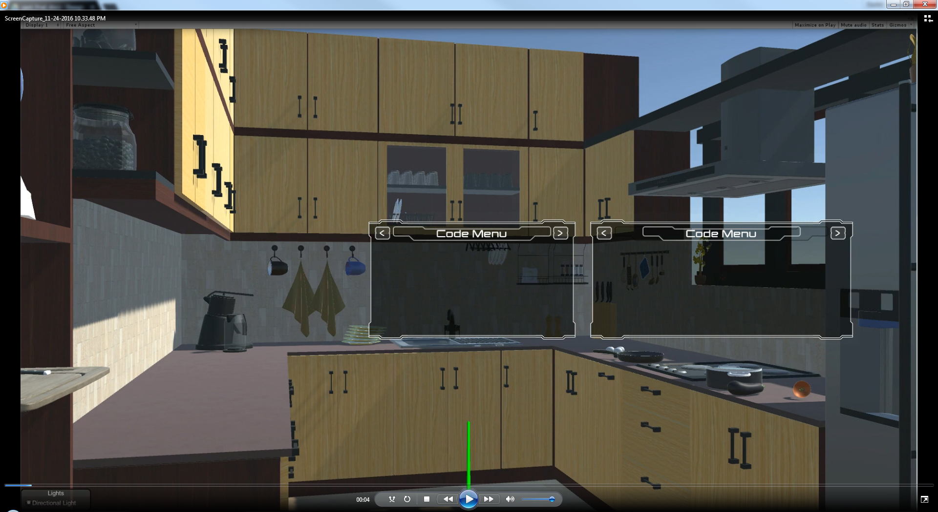

##### Fig B.1 - Virtual kitchen

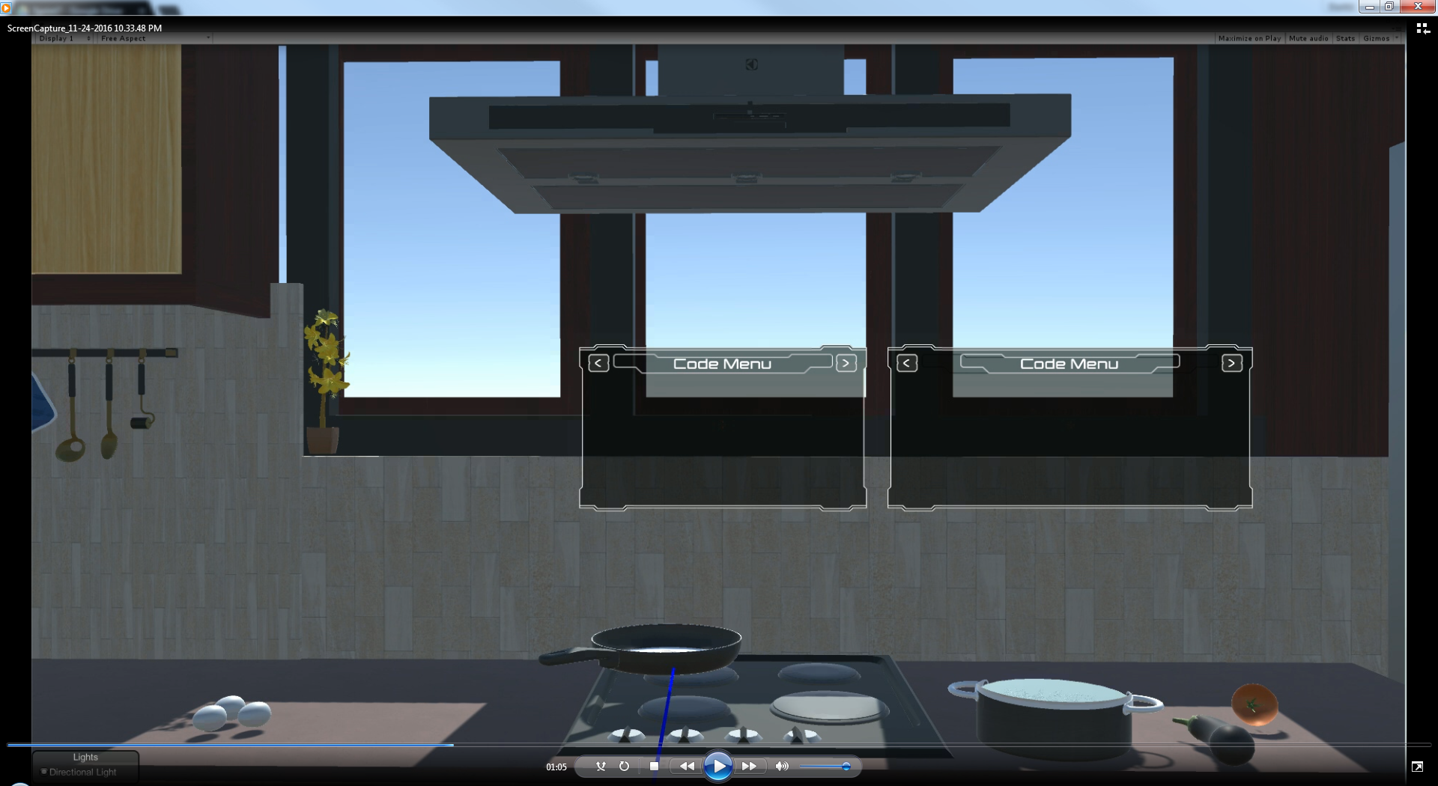

##### Fig B.2 - Using the GrabbingWand to move a stoveObject

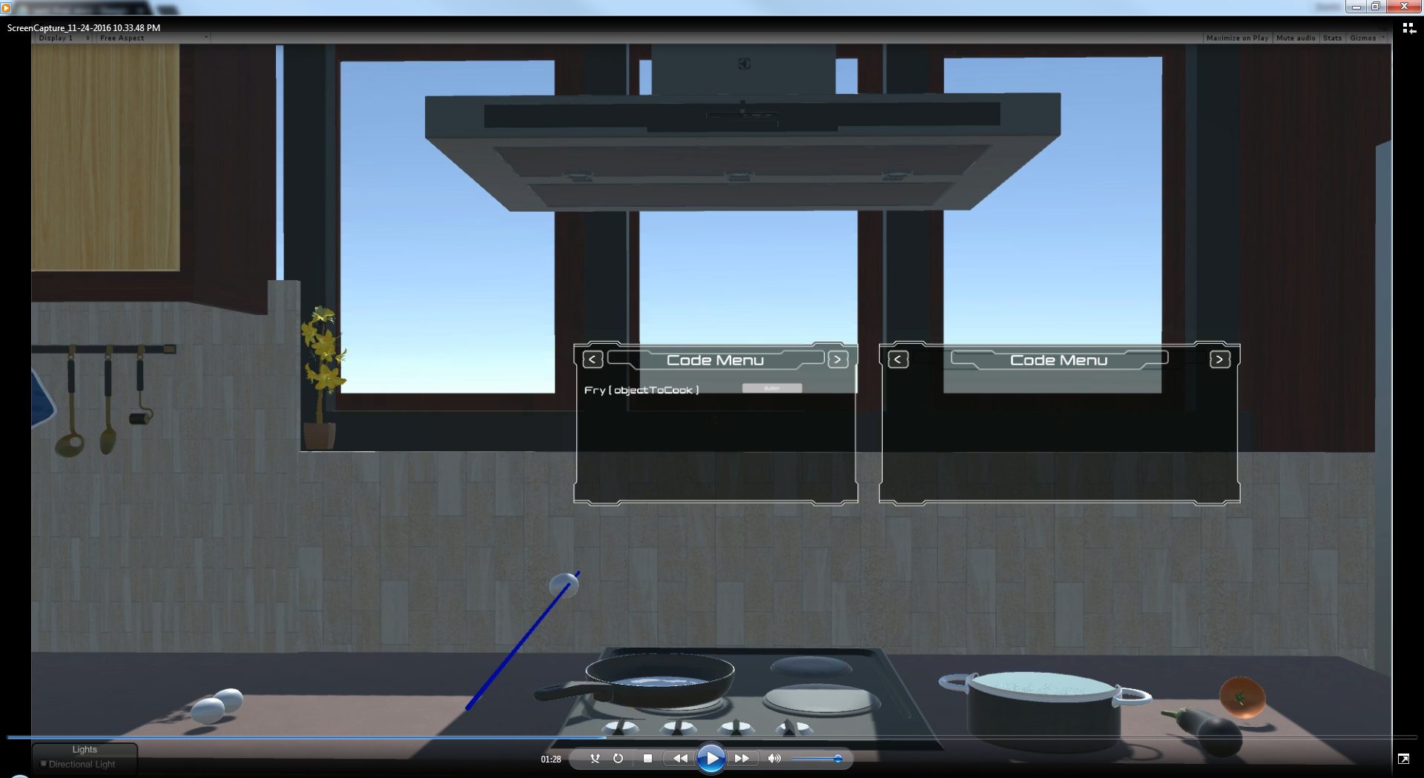

##### Fig B.3 - Using the GrabbingWand to move a foodItem

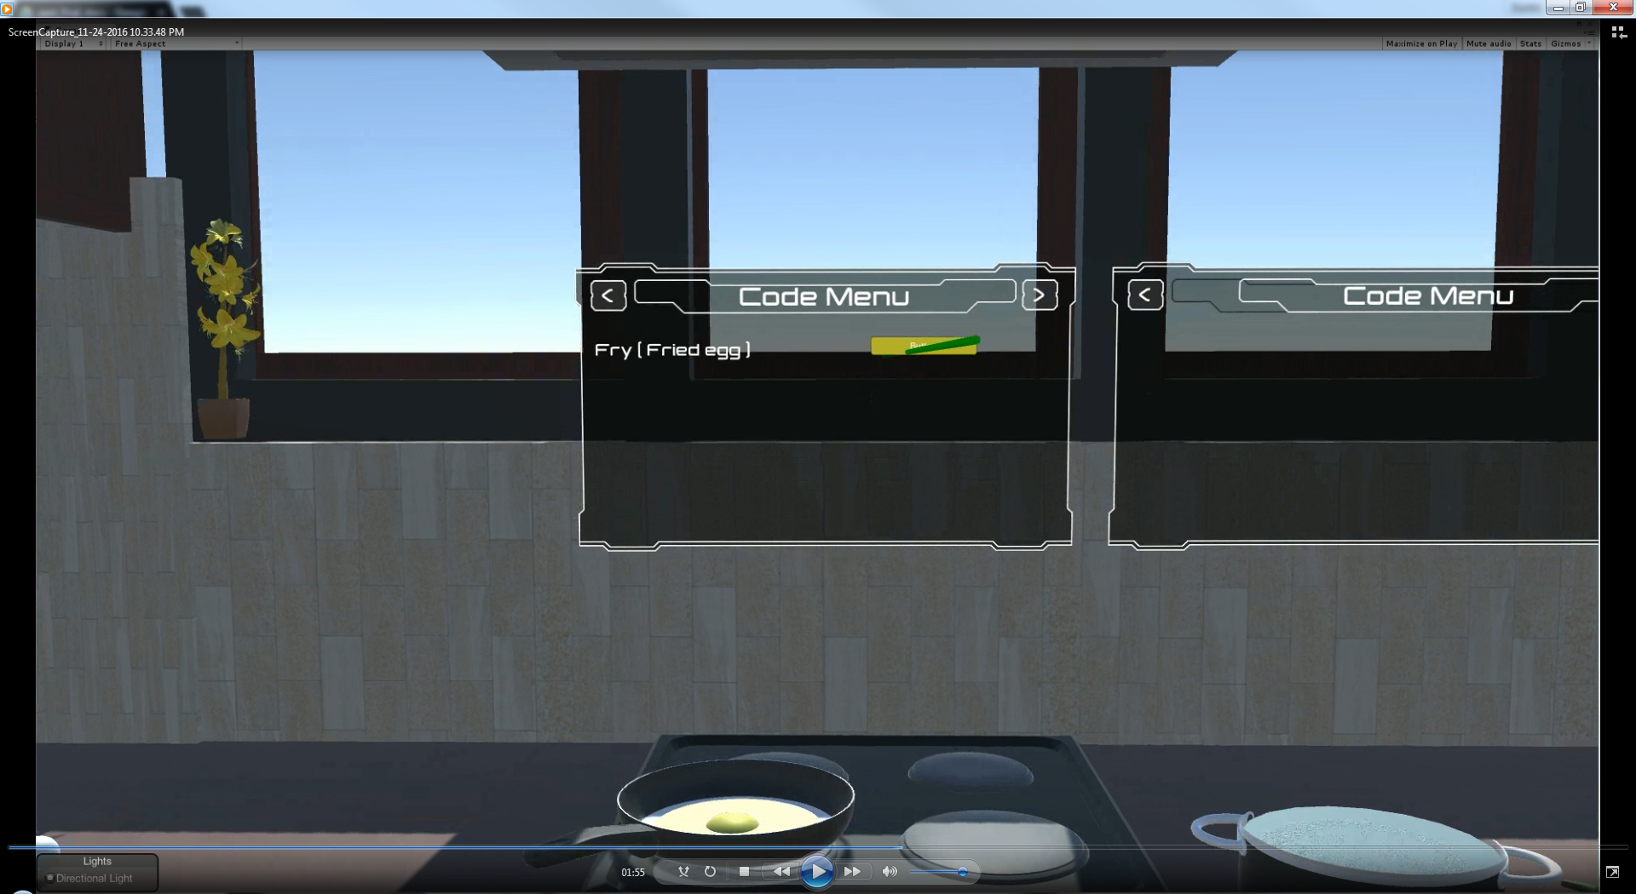

##### Fig B.4 - Using the PointingWand to interact with the button in Code Menu

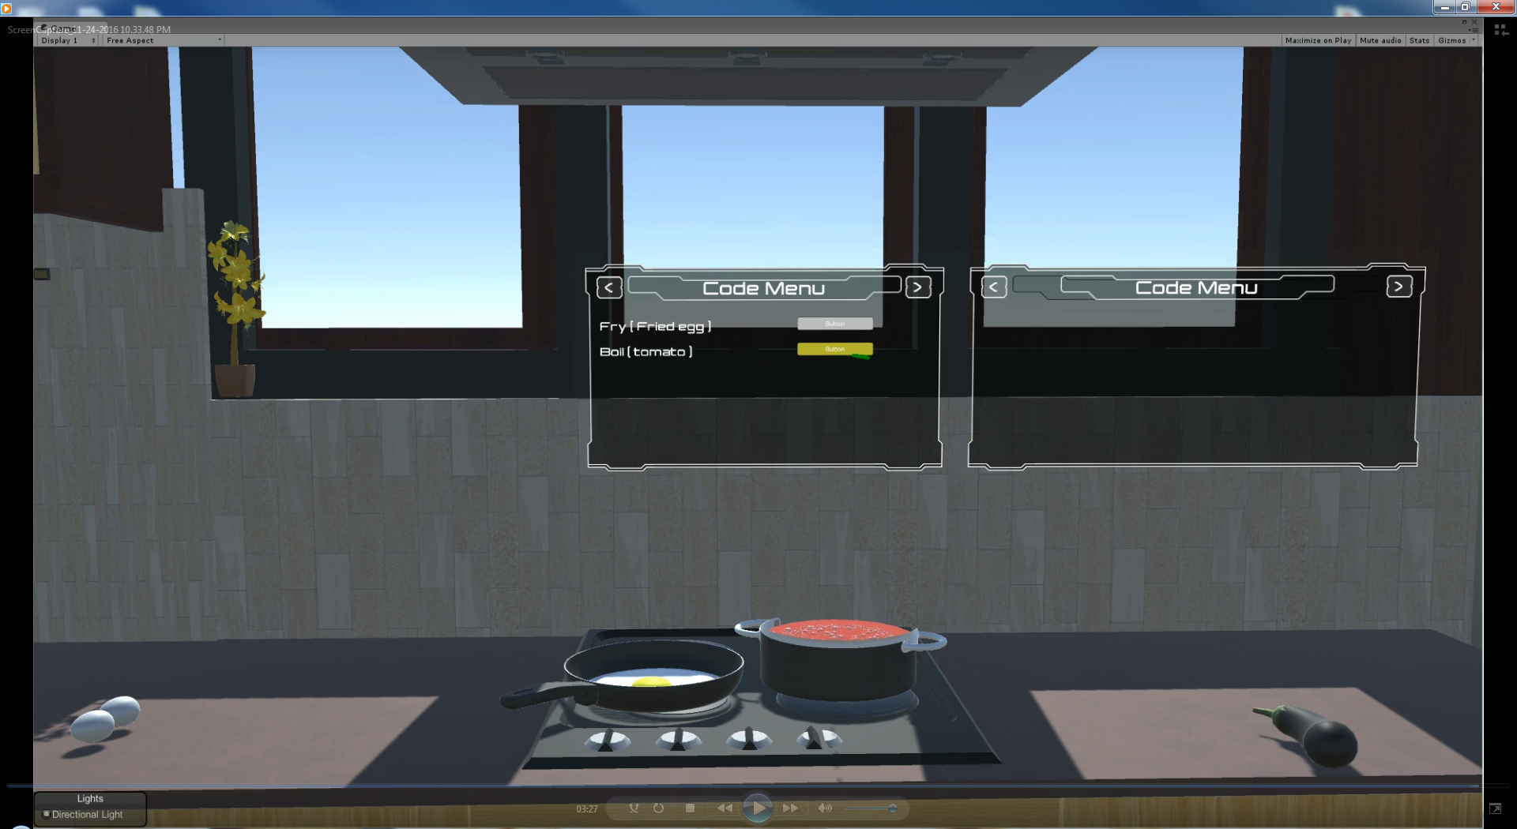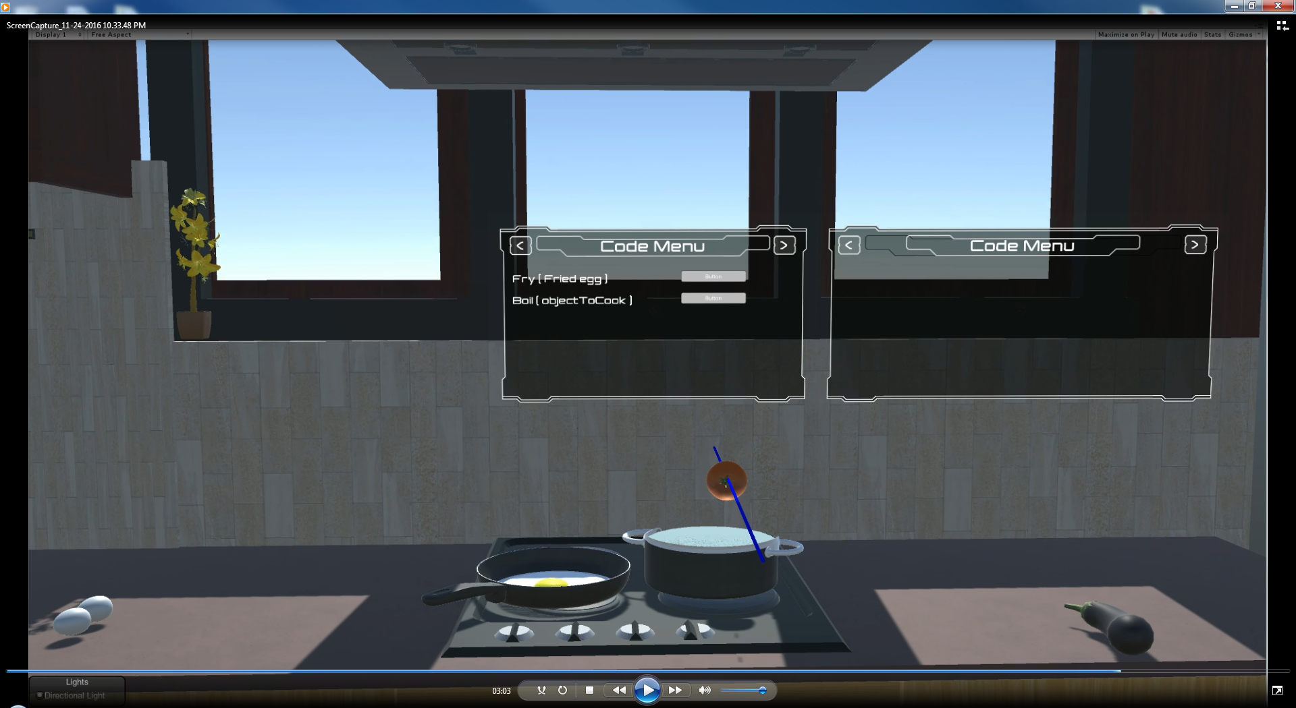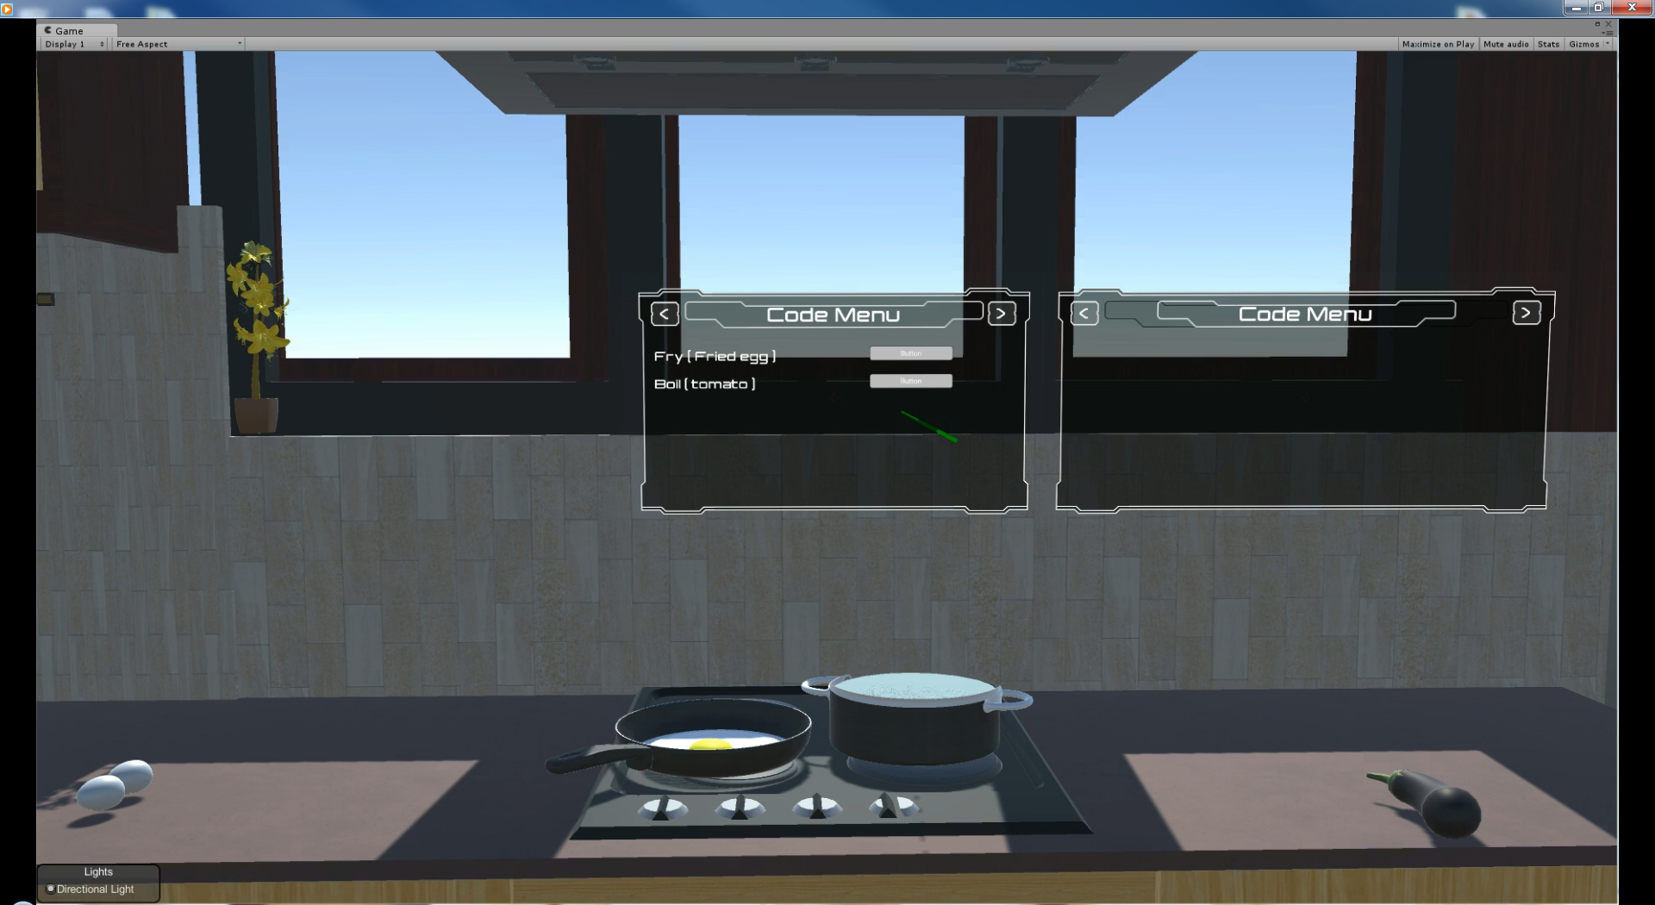

##### Fig B.5 - Creating tomato soup by placing a tomato in the cooking pot.

## 

##### Fig B.6 - Code menu updates when FoodItem is placed on PlatformObject

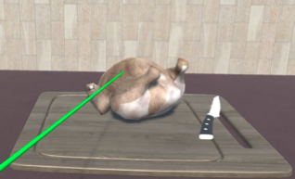

##### Fig B.7 - Pointing wand is used to point at the FoodItem to start process

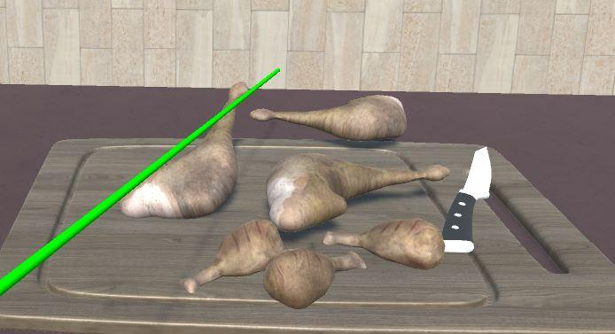

##### Fig B.8 - Chopping process is carried out and the unchopped FoodItem is replaced with the chopped FoodItem

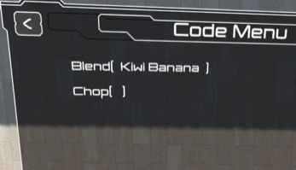

##### Fig B.9 - The Code Menu is updated with the FoodItem removed from *Chop()*

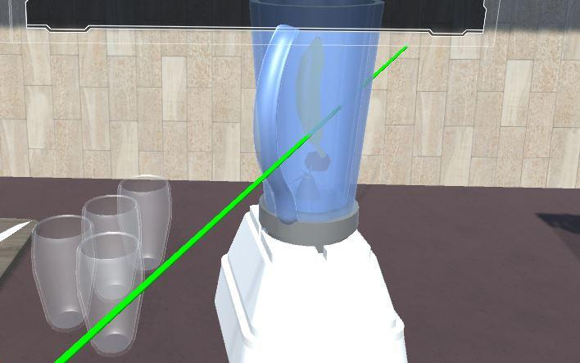

##### Fig B.10 - The glasses are placed on the platform, the pointing wand is pointed at the blender and the wand button is pressed

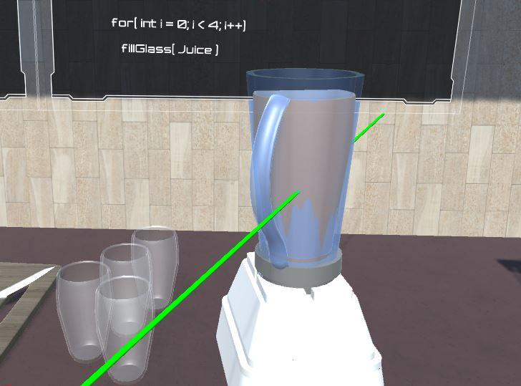

##### Fig B.11 - The display is updated with the loop and the blending process is carried out, replacing the fruits inside the blender with juice

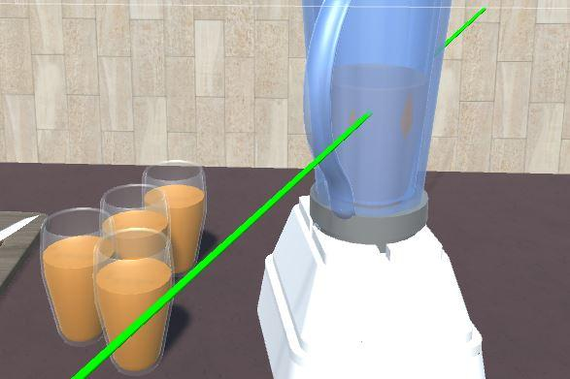

##### Fig B.12 - The juice in the blender is emptied and the glasses are filled out

## 

## 

## 

## Appendix C - Sprint Review Reports

**Sprint Review 1**

Attendees: Alain, Derrick, Dhrumel, Chetan, Francisco

Start time: 7:45pm

End time: 8:20pm

After a show and tell presentation, the implementation of the following user stories were accepted by the product owners: All.

* Learn Unity #926
* Learn getReal3D plugin #934
* Learn Mingle/Scrum/Agile #944
* Learn C# #941
* Lean getReal3D plugin #927
* Learn Mingle and Scrum #929
* Learn Unity #948
* Learn C# #932
* Learn Unity #982
* Learn C# #988
* Familiarize with Mingle and Scrum #963
* Learn about implementing hololens on unity #994
* Learn how to use Mingle/Scrum/Agile #974
* Learn Unity to be able to create 3D environments #945
* Learn C# to develop on Unity #943
* Learn Hololens PLatform for development on Unity #935

The following ones were rejected and moved back to the product backlog to be assigned to a future sprint at a future Spring Planning meeting.

* None

**Sprint Review 2**

Attendees: Alain, Derrick, Dhrumel, Chetan, Francisco

Start time: 7:20pm

End time: 7:40pm

After a show and tell presentation, the implementation of the following user stories were accepted by the product owners:

* Training for I-Cave #955
* Project Plan #1008
* Develop Unity VR Games #1026
* Do the training for the FIU I-CAVE #942
* Come up with a project #1014
* Complete more advanced tutorials in Unity #1029
* Develop the Game #1009
* Learn advanced techniques used in Unity and C# #1032
* Allow user to manipulate holograms with gestures #946
* Create game board#1046

The following ones were rejected and moved back to the product backlog to be assigned to a future sprint at a future Spring Planning meeting.

* View the kitchen facility #962 (Task required more time, and resources to complete)
* Move items in the kitchen #1023 (Task required more time, and resources to complete)
* Develop basic functionalities on Unity #952 (Task required more time, and resources to complete)
* Develop basic environment in Unity #949 (Task required more time, and resources to complete)
* Manipulate Holograms with gestures & voice #1002
* Allow users to collaborate with other hololens users #1000 (Task not relevant to project anymore)
* InteractMaze #1035(Task still needs testing, and one new additional feature)

**Sprint Review 3**

Attendees: Alain, Derrick, Dhrumel, Chetan, Francisco

Start time: 10/9 6:55pm

End time: 7:15pm

After a show and tell presentation, the implementation of the following user stories were accepted by the product owners:

* View the kitchen facility #962
* Move items in the kitchen #1023
* View pseudo-code #960
* Develop basic functionalities on Unity #952 (Display and update text)
* Develop basic environment in Unity #949 (Renamed to Environment in Unity)
* Design Game Board#1056
* Design Buttons#1057
* InteractMaze #1035

The following ones were rejected and moved back to the product backlog to be assigned to a future sprint at a future Spring Planning meeting.

* Fix Visual Studio #1066 (Technician has not been able to fix the issue)
* Create boiling water in Unity #1031 (Removed)
* BeginGame#1034(Task still needs testing)

**Sprint Review 4**

Attendees: Alain, Derrick, Dhrumel, Chetan, Francisco

Start time: 10/23 6:05pm

End time: 6:25pm

After a show and tell presentation, the implementation of the following user stories were accepted by the product owners:

* Use various ingredients and equipment #1050
* View pseudo-code on a screen #1051
* Screen inside of the game #1065
* Fix Visual Studio #1066
* More objects in the kitchen #1074
* BeginGame #1034
* PlayGame #1073
* ViewGameInfo #1096
* Test Game #1092
* Develop UI for Maze#1105

The following ones were rejected and moved back to the product backlog to be assigned to a future sprint at a future Spring Planning meeting.

* None

**Sprint Review 5**

Attendees: Alain, Derrick, Dhrumel, Chetan, Francisco

Start time: 11/07 9:30pm

End time: 9:50pm

After a show and tell presentation, the implementation of the following user stories were accepted by the product owners:

* Use all facilities of the kitchen #1078
* View pseudo-code for all functionalities #1081
* Add button to begin animations #1109
* See object/parameter that the function is using #1087
* EndGame#1104

The following ones were rejected and moved back to the product backlog to be assigned to a future sprint at a future Spring Planning meeting.

* View cooking process/output #1112
* Animations #1089
* InteractEvent#1037

**Sprint Review 6**

Attendees: Alain, Derrick, Dhrumel, Chetan, Francisco

Start time: 11/18 8:35pm

End time: 8:50pm

After a show and tell presentation, the implementation of the following user stories were accepted by the product owners:

* View cooking process/output #1112
* View looping functionality #1114
* Animations #1089
* ResetGame #1132

The following ones were rejected and moved back to the product backlog to be assigned to a future sprint at a future Spring Planning meeting.

* InteractEvent#1037

## 

## Appendix D - User Manual, Installation/Maintenance Document, Shortcomings/Wishlist Document

## User Manual

**Virtual Kitchen**

When the application starts, you will be positioned at the entrance of the kitchen where you can get a complete view of all its components. The Code Menu will be displayed in front of you, and will move with you as you navigate around the kitchen with the hand-controller. You will also be able to use 2 wands, the grabbing wand and the pointing wand, both of which are described below.



Fig. D.1 – Virtual Kitchen

**GrabbingWand**

The GrabbingWand can be used to grab and move objects in the virtual kitchen. To do so:

1. Press the Select Wand button on the controller until the blue-colored wand has been selected.
2. Point the wand towards an object, making sure that it goes through the object.
3. While the wand is going through the object, press down and hold the Activate Wand button.
4. The object will be attached to the wand as long as the Activate Wand button is held down.
5. You can move the object around by moving the wand.
6. You can walk while you are grabbing an object.
7. To release the object, release the Activate Wand button.

Notes: Only one object can be grabbed at once. The Grab function makes some objects go through walls, floor, etc.



Fig. D.2 - Using the GrabbingWand to move a stoveObject and a foodItem

**PointingWand**

The PointingWand can be used to press the button of the Code Menu. To do so:

1. Press the Select Wand button until the green-colored wand has been selected.
2. Point the wand towards the button you wish to press.
3. The button will highlight indicating that the wand is on top of the button.
4. Once the button has highlighted, press on the Activate Wand button to activate the Menu Code button.
5. The PointingWand does not collide with other objects. It can be moved around and will go through any other object.



Fig. D.3 - Using the PointingWand to interact with the button in Code Menu

**Cooking a foodItem** (Fig. B.5)

FoodItems can be placed on stoveObjects that are on the stove. This will activate the button on the Menu Code with the foodItem’s corresponding cook function. The process to cook a foodItem is as follows:

1. Use the GrabbingWand to place a stoveObject on top of the stove.
2. Use the GrabbingWand to place a foodItem on top of the unoccupied stoveObject.
3. Locate the Menu Code and the line of code that corresponds to the foodItem-stoveObject combination.
4. Using the PointingWand, press on the button next to the line of code from the previous instruction.
5. Once the button is pressed, the cooking function will execute and a new output will display.

Notes:

1. Only one foodItem can be cooked at a time.
2. Steps 1 and 2 can be interchanged but it is not suggested (bugs).
3. The boiling pot can only be used once per execution of game.
4. The frying pan can be used multiple times during one execution of game.
5. To remove a foodItem from the frying pan, grab the frying pan and tilt it so that the foodItem slides of the pan. (The food is too hot to be grabbed directly!)

**Object Interactions** (for Stove Objects)

StoveObjects

* Frying pan
* Boiling Pot

FoodItems-Fry

* Egg
* Chicken (after chopping)
* Cheese (after chopping)
* Fries (after chopping potato)

FoodItems-Boil

* Tomato
* Eggplant

Items from stoveObjects list can be placed on top of the stove. Doing this will start a function call. Then an item from the foodItems list can be placed in its corresponding stoveObject. FoodItems from the Fry list do not execute cook function when they are in the boiling pot and vice-versa for the items in the Boil list.

**Chopping Food Items** (See references to Appendix B below for the visual)

There are several food items that you can use for chopping. Proceed as follows:

1. Use the Grabbing Wand to grab the chopping board from the shelf and place it anywhere on the platform
2. You will see the Code Menu update with the function *Chop()*
3. Go back to the shelf and grab one of the food items that can be chopped (see Object Interactions for which items have the chopping functionality)
4. Place the food item on the chopping board
5. You will see the Code Menu update with the function *Chop(FoodItem)* (Fig B.6)
6. Using the Pointing Wand, point at the food item or the chopping board, and then activate the wand (Fig B.7)
7. You will see the food item chop into pieces (Fig B.8)
8. You can continue to use the chopping board for other items as the display is updated with the chopped item removed (Fig B.9)

Note: You can place multiple items on the chopping board at once and chop them all together, or even do them individually

**Blending Food Items** (See references to Appendix B below for the visual)

There are several food items that you can use for blending. Proceed as follows:

1. Use the Grabbing Wand to grab the blender from the shelf and place it anywhere on the platform
2. You will see the Code Menu update with the function *Blend()*
3. Go back to the shelf and grab the food items that can be blended (see Object Interactions for which items have the blending functionality)
4. Place the food item in the blender, one at a time
5. You will see the Code Menu update with the function *Blend(FoodItem)*
6. Again go back to the shelf and grab a certain number of glasses you want filled with the blended juice
7. Place these glasses on the platform next to the blender
8. Using the Pointing Wand, point at the food items or the blender, and then activate the wand (Fig B.10)
9. You will see the food items blended into juice (Fig B.11)
10. The Code Menu then displays a loop to fill out each glass with juice (Fig B.11)
11. The glasses are filled out one at a time, while an equivalent amount of juice is emptied from the blender (Fig B.12)

Note: You can place multiple items in the blender at once and blend them all together, or even do them individually

**Object Interactions**

PlatformObjects

* Chopping Board
* Blender

FoodItems that can be chopped

* Chicken
* Potato
* Cheese

FoodItems that can be blended (any fruit)

* Banana
* Kiwi
* Watermelon
* Mango

## Installations and Maintenance

To run the application, simply transfer the .exe file from the GitHub Repository to the FIU ICAVE. To edit the project and create a new application, proceed as follows:

1. Use a computer with Windows 7 or Windows 10 operating system
2. Go to the GitHub Repository, download the zip file and save the “Assets” folder somewhere easily accessible

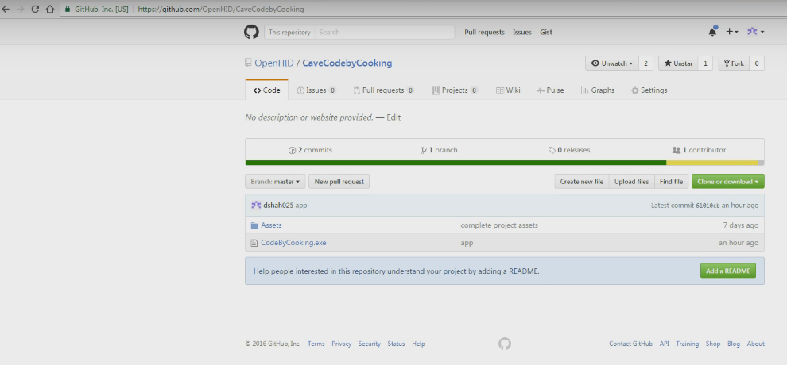

Fig. D.5 – GitHub Repository

1. Download Unity 5.3.2 from the following link <https://unity3d.com/get-unity/download/archive>

Must use version 5.3.2.

1. Download the GetReal3D plugin from the following link <http://icave.fiu.edu/getReal3D_for_Unity_3.3.0_x64.exe>

Note that this is a later version of GetReal3D than the one used for this project. If you have the project files with the assets, then this will not create an issue.

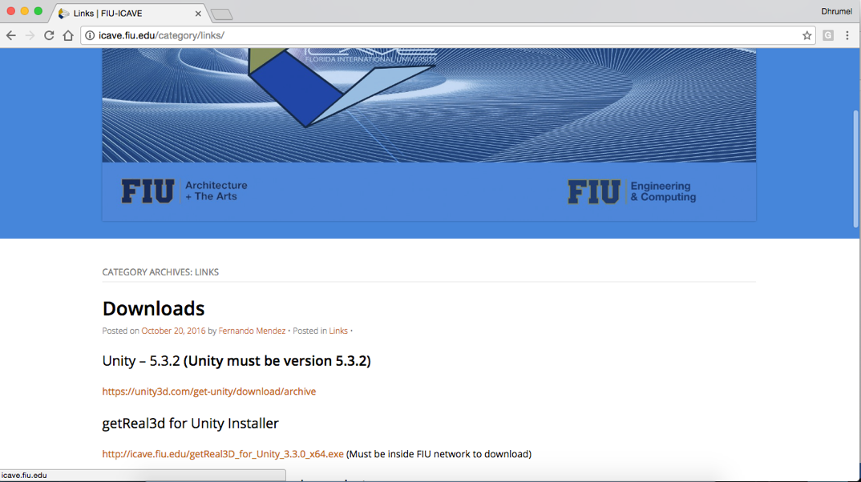

Fig. D.5 – I-CAVE Website with download links

1. Run Unity, create a New Project and then close Unity

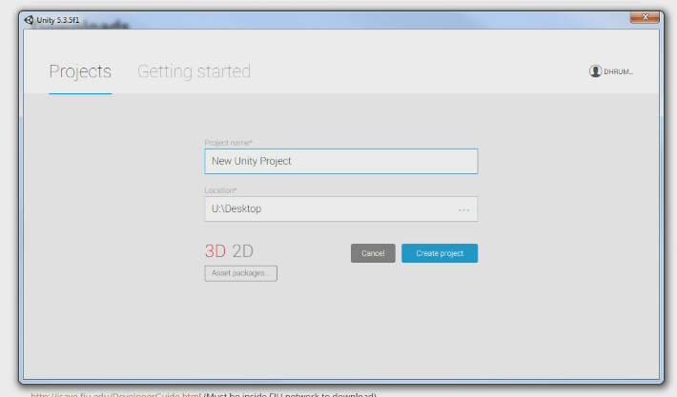

Fig. D.6 – Creating a New Project in Unity

1. Drag and drop the Assets folder you downloaded from GitHub to the New Project Folder

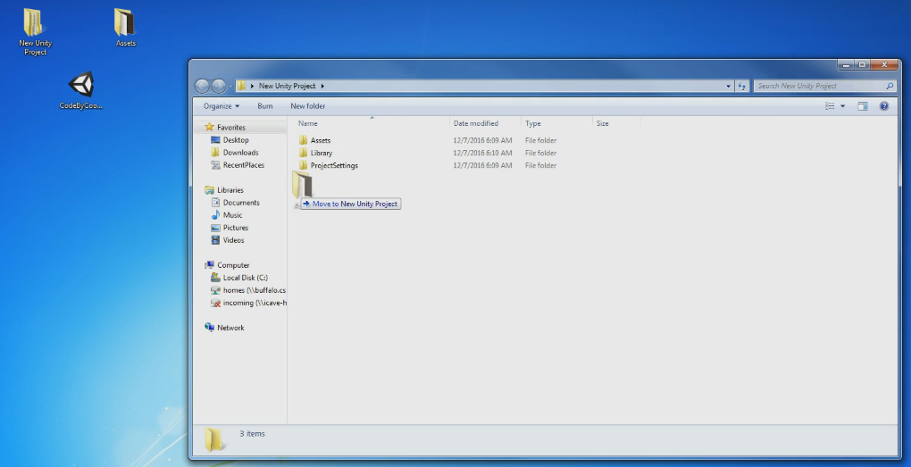

Fig. D.7 – Drag and drop Assets folder

1. Open “Kitchen Test Scene” from the assets if it is not already open
2. Go to File -> Build Settings and build your .exe application file

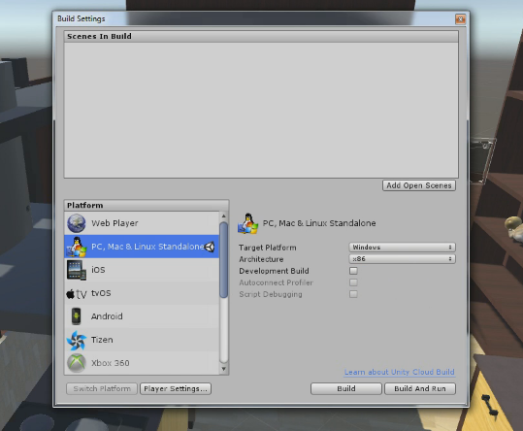

Fig. D.8 – Build the application

1. Save this .exe file and transfer it to the head node of the main I-CAVE machine
2. Ensure that the dtrack, trackd and GetReal3D programs are running on the machine
3. Add the file to the GetReal3D cluster
4. Launch the application
5. Turn on the projectors
6. Wear the 3D goggles with the tracking device, grab the gamepad, enter the I-CAVE and you’re good to go

For maintenance, if you use the project files with the same GetReal3D folder, you should have no issues in running the application. However, the Unity on the main I-CAVE machine needs to support the Unity version with which you build the application. As long as Unity in the I-CAVE machine is the current version, you may use Unity 5.3.2 to build your application. In case there are any upgrades and the application does not run, contact the I-CAVE staff at FIU.

## Shortcomings and Wishlist

Since we were the first Senior Project students to work on the I-CAVE, we faced some issues such as limited access and different Unity versions in the I-CAVE head node, I-CAVE lab, and Graduate student lab. Hence, we were not able to work on a few functionalities as per our initial plan. However, these would only be minor additions, as what we have built is a complete application by itself. We would have liked to add:

* A voice that adds to the explanation of programming concepts and guides the user
* Animations and audio to the cooking process for a more realistic feel
* Concept of objects by assigning a class to one cooking session, so that future sessions can simply use items that have already been cooked, i.e. call the functions that have already been implemented. We basically want the student to understand, “If the food has already been cooked before, why should I make it again when I can simply take it out of the refrigerator and reheat?” Reheating is similar to instantiating an object.
* More objects and their interactions which would provide the user with a complete cooking and learning experience
* An input device like a VR-Glove which would make interaction more realistic for the user. It would be great if the ICAVE invests in it before the next team begins working on the project.

# 

# 

# References

* <https://unity3d.com/get-unity/download/archive>

Source for downloading the Unity application`

* <http://icave.fiu.edu/category/links/>

GetReal3D plugin source

* <http://icave.fiu.edu/about/>

I-CAVE specifications

* <https://www.mechdyne.com/software.aspx?name=getReal3D+for+Unity>

GetReal3D specifications

* <https://www.thoughtworks.com/mingle/docs/welcome_to_mingle.html>

For our User Stories

* <https://www.udemy.com/if-you-can-cook-you-can-code/>

Related applications that have been implemented

* <http://www.turbosquid.com/Search/3D-Models/free>

Source for 3D models

* <https://www.cgtrader.com/3d-models>

Source for 3D models